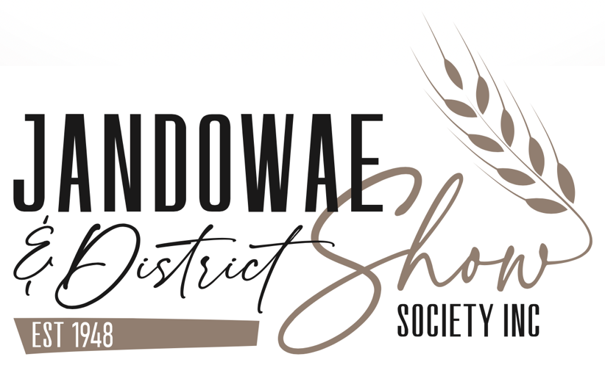
President: Valerie Murray
Secretary: Christine Farmilo
Treasurer: Leanne Roberts

Address: PO Box 112, Jandowae Q 4410
Email: jandowaeshow@gmail.com
Website: www.jandowaeshow.com

Show Date: 23rd March, 2024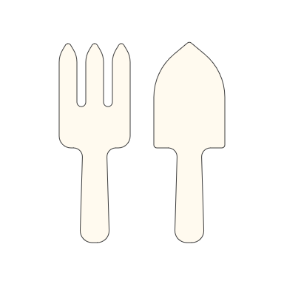
2024 Show Theme “The Country Garden”

Name & Address Email/Phone Number

__________________________________ ________________________________

__________________________________ ________________________________

__________________________________ ________________________________

Membership (Adults only) $15 per person. Number required: _______ x $15 = $ ________
Age Concession $10 per person. Number required: _______ x $10 = $ _______
Your membership grants you free admission on Show Day
Please list members’ names below

__________________________________ ________________________________

__________________________________ ________________________________

Admission Charges: Adult - $15
Age Concession - $10
Student Concession (ages 5-18) - $5
Under 5 – Free

If you would like to give additional support towards the cost of our Annual Show, any donation would be most appreciated.
Acknowledgement of all donations will be on our Website.

$______ Amount of donation. General / Rodeo / Specific _____________________________

Please advise details: Section/Family Trophy etc.____________________________________

Total Donation: $__________ Total Enclosed: $______________

Direct Bank Details:
BSB: 014570 ACC: 388504554
Ref: Surname & Initials. Please also return this form.

Receipts & complimentary gate tickets will be sent out prior to our 2023 Show.

Please remember you can find all schedule information on our website.

